Before fiscal year 2007, an independent contractor estimated that, nation-wide, Indian Housing Block Grant recipients built or acquired 12,147 homeownership units and 5,289 rental units.
The figures in the chart below come from the HUD-ONAP Performance Tracking Database.
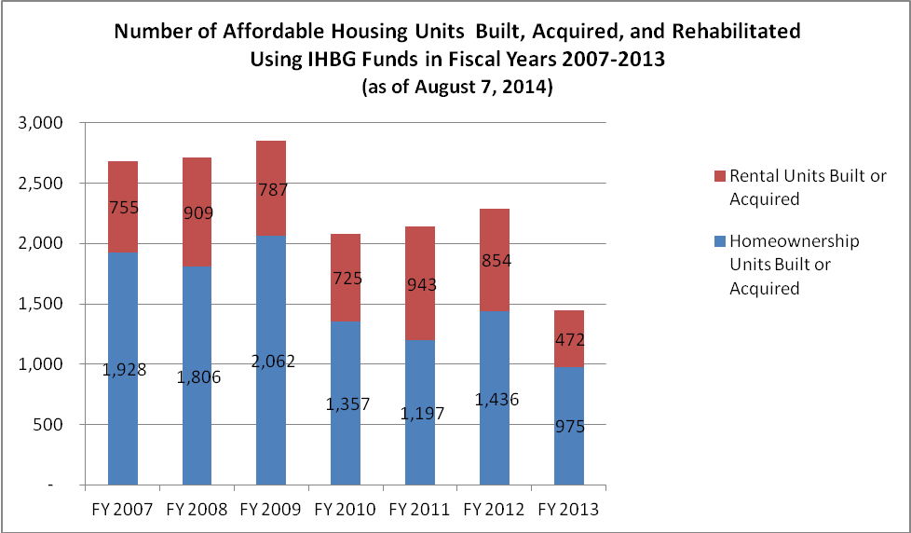
Homeownership Units 1998-2006: 12,147
Homeownership Units 2007-2013: 10,761
Total Homeownership Units 1998-2013: 22,908
Rental Units 1998-2006: 5,289
Rental Units 2007-2013: 5,445
Total Rental Units 1998-2013: 10,734
Total Homeownership and Rental Units Developed 1998-2013: 33,642 units.
* The data in the Performance Tracking Database represents the number of “NAHASDA units” as reported by the grantees. Data before 2007 is an estimate, provided by an independent contractor.
A unit is considered a “NAHASDA unit” if
- any NAHASDA funds were used, alone or in combination with other funds, to build, acquire, or substantially rehabilitate it, AND
- the unit is not an FCAS unit. FCAS units, (or Formula Current Assisted Stock) are units that were funded, alone or in part, by programs authorized under the U.S. Housing Act of 1937.

